Men's A
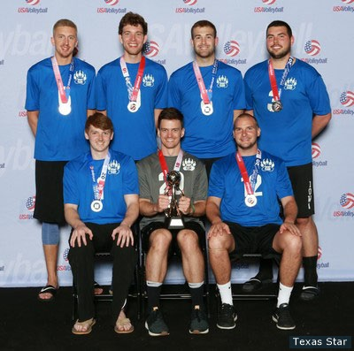
Team Bear Claw (Iowa) - Men's A Division 2nd Place
Front Row (L-R): Joseph Biros, Kyle Bolinder, Daniel Dowjotas
Back Row (L-R): Hunter Sade, Tyler Willis, Taylor Heue, Logan Hansen
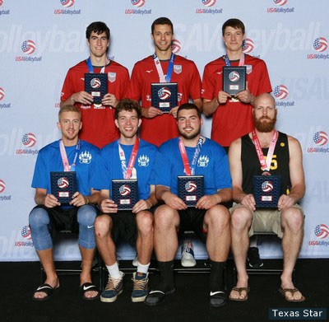
Men's A Division All-Tournament Team
Front Row (L-R): Hunter Sade (Team Bear Claw), Tyler Wills (Team Bear Claw), Logan Hansen (Team Bear Claw), Blake Allen (ZO-U)
Back Row (L-R): John Valerias (Fathers & Sons), MVP - Will Price (Fathers & Sons), Michael Saeta (Fathers & Sons)

Women's A
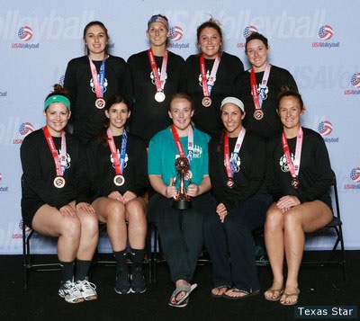
Team Bearclaw (Iowa) - Women's A Division 3rd Place
Front Row (L-R): Brittney Burmahl, Jessica Carlson, Riley Banes, Kiley Haines, Taylor Martin
Back Row (L-R): Brianna Strong, Ashten Stelken, Becca Bell, Marci Novak
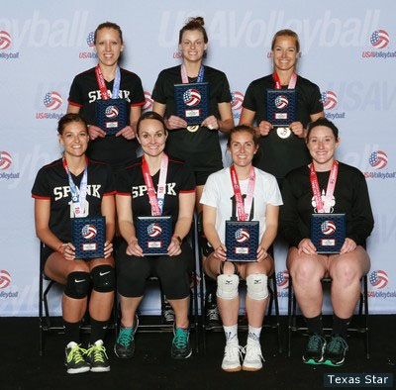
Women's A Division All-Tournament Team
Front Row (L-R): Kristy Bourquin (SPANK), Kate Langfeldt (SPANK), Jennifer Smith (Shots), Marci Novak (Team Bearclaw)
Back Row (L-R): Kalli Lochner (SPANK), MVP - Stacey Smith (Shots), Patti Cook (Shots)

Women's B
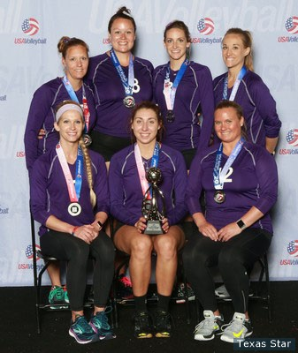
Boom (Iowa) - Women's B Division 2nd Place
Front Row (L-R): Megan Nieman, Cori Peterzalek, Jenna Felsing
Back Row (L-R): Christina Groesch, Jesicah Ambrisco, Megan Delcourt, Lindsay Scott
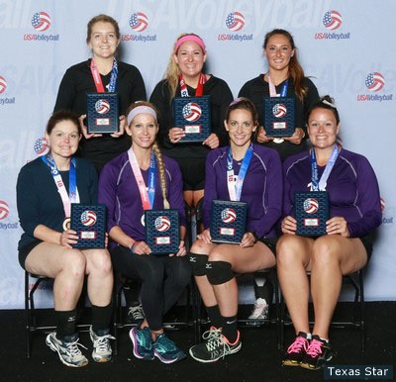
Women's B Division All-Tournament Team
Front Row (L-R): Amanda Clyne (Lady Chickens), Megan Nieman (Boom), Megan Delcourt (Boom), Jesicah Ambrisco (Boom)
Back Row (L-R): Samantha Higgins (Hit-Faced), MVP - Samantha Salwa (Hit-Faced), Jennifer Duggan (Hit-Faced)

Women's Open
TEAM (REGION) - Women's Open Division 1st Place
Front Row (L-R): Allegra Wells, Katherine Bell, Sha'Dare McNeal, Carnae Dillard, Chloe Collins
Back Row (L-R): Head Coach Victoria Thomas, Jenelle Jordan, Chanelle Gardner, Kaz Brown, Haley Eckerman, Erin Fairs
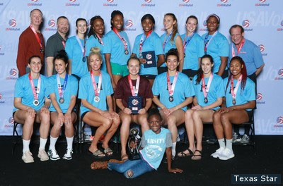
Hoosier Terminator (Hoosier) - Women's Open Division 2nd Place
Front Row: Julianne Arruda
Middle Row Row (L-R): Samantha Middleborn, Lindsay Dowd, Rese McNatt, Alexandra Reid, Michelle Strizak, Tiana Dockery
Back Row (L-R): Unknown, Assistant Coach Don Cohen, Erica Handley, mara Green, Annayka legros, Sareea Freeman, Taylor Fricano, Kayla Haneline, Danielle Scott-Arruda, Head Coach Steve Warren
Women's Open Division All-Tournament Team
Not Present (L-R): MVP - Haley Eckerman (Team Dream), Alexandra Karelov (Hoosier Exterminators), Katherine Bell (Team Dream), Abby Detering (Team Freedom), Erin Fairs (Team Dream), Sareea Freeman (Hoosier Exterminators), Chloe Collins (Team Dream).

Men's 55-and-Over
Western States Laguna (Southern California) - Men's 55-and-Over Division 1st Place
Front Row (L-R): Steve Rottman, Lindon Crow, Harold Noriega, Steve Vrebalovich, Steve Zelko, Todd Miller, Commander Holcomb
Back Row (L-R): Jim Hall, Joel Rodgers, Anthony Cothron, Mike Hopton, Steve Friedman, David Strege, Assistant Coach Rose Rahn, Ali Tazerouni, John McColl

Men's 60-and-Over
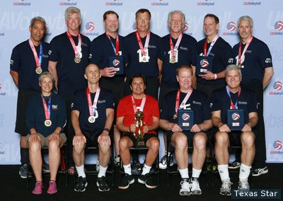
Federal Resources (Heart of America) - Men's 60-and-Over Division 1st Place
Front Row (L-R): Eva Sagiao, Keith Iverson, Harold Noriega, Rod Wilde, Jerry Kukuruda
Back Row (L-R): Malu Sagiao, Peter Morris, Dave Strege, Jack Henderkott, Dale Hoffman, Steve Sargis, Ray Elsman
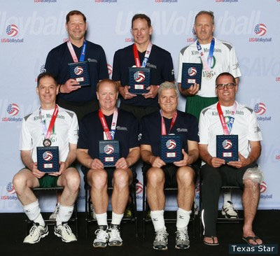
Men's 60-and-Over Division All-Tournament Team
Front Row (L-R): David Unietis (Kings Mountain Fog 60), Rod Wilde (Federal Resources), Jerry Kukuruda (Federal Resources), Ken Link
Back Row (L-R): Dave Strege (Federal Resources), MVP - Steve Sargis (Federal Resources), Yuri Federov (Kings Mountain Fog 60)

Men's 70-and-Over
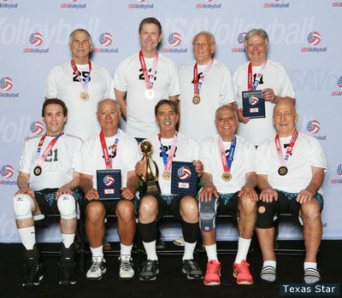
Quiksilver Legends 70 (Southern California) - Men's 70-and-Over Division 1st Place
Front Row (L-R): Ivan Dekovic, Richard Leong, Paul Mitchell, Ahmad Vossoughi, Terry Sheward
Back Row (L-R): Frank Swain, Jerry Weydert, Will Lapp, Harold Reiser
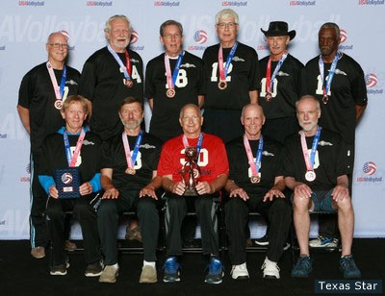
Papakoa 70 (Great Lakes) - Men's 70-and-Over Division 3rd Place
Front Row (L-R): Otis Mitchell, Joseph Gogulich, John Wilder, Robert Frazer, Bruce Schmeiser
Back Row (L-R): Tim Keenan, Bruce Murff, Larry Rickmann, Rob Loughheed, Henry Dahlen, Robert Jack

Men's 73-and-Over
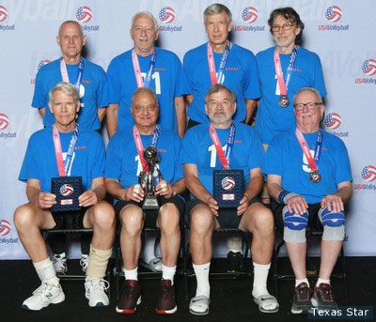
Rustys 73 (Columbia Empire) - Men's 73-and-Over Division 2nd Place
Front Row (L-R): John Spitzer, Surj Sanghera, Gary Pfingsten, Brian Marts
Back Row (L-R): Dennis Horn, Harry Siemen, John Dapkis, Jack Laffe
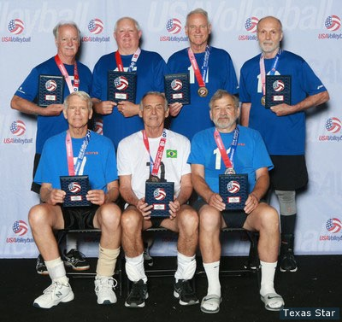
Men's 73-and-Over Division All-Tournament Team
Front Row (L-R): John Spitzer (Rustys 73), Sergio Telles (V&C/Brasil M73+), Gary Pfingsten (Rustys 73)
Back Row (L-R): Richard O'Toole (Son of a Beach), MVP - Gordon Johanson (Sun of a Beach), Dennis Schneider (Son of a Beach), Joe Ritzenthaler (Son of a Beach)

